Lab6 Report
Content
1.hello-minikube 2
1.1 Create a minikube cluster 2
1.2 Create a Deployment 2
1.3 Create a Service 4
1.4 Enable addons 4
2.Using kubectl to Create a Deployment 5
2.1 Deploy an app 5
2.2 View the app 5
3. Viewing Pods and Nodes 6
3.1 Check application configuration 6
3.2 Executing commands on the container 7
4. Using a Service to Expose App 7
4.1 Creating a new Service 7
4.2 Using labels 8
4.3 Deleting a service 9
5. Running Multiple Instances of our App 9
5.1 Scaling a Deployment 9
5.2 Scale Down 10
6. Performing a Rolling Update 11
6.1 Update the version of the app 11
6.2 Verify an update 11
6.3 Roll back an update 11

1.hello-minikube

1.1 Create a minikube cluster
First, create a minikube cluster.
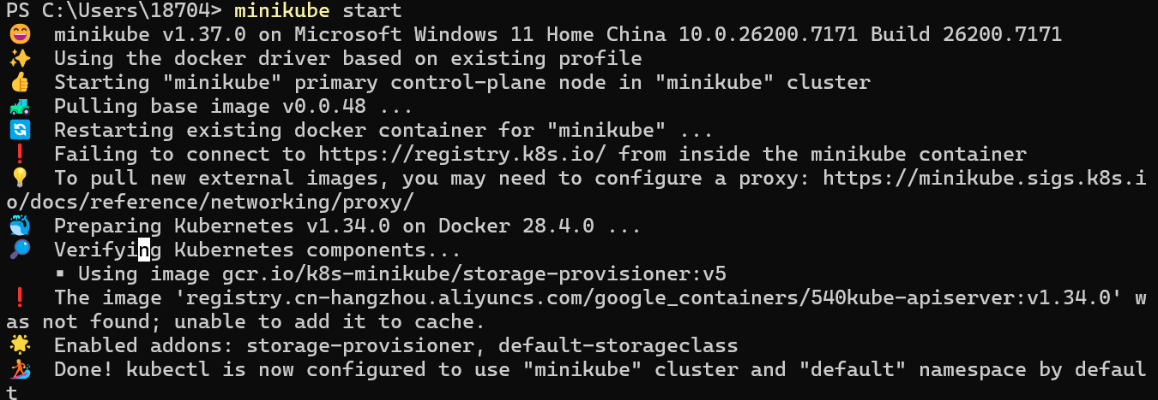
Open the Kubernetes dashboard.
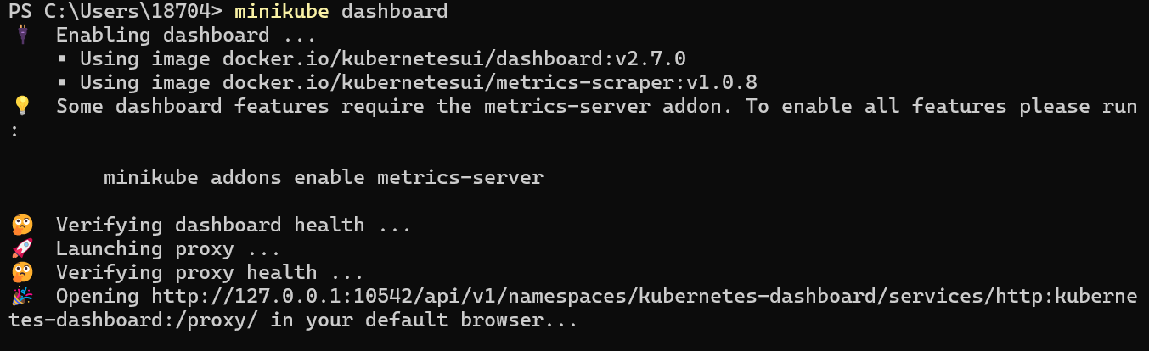
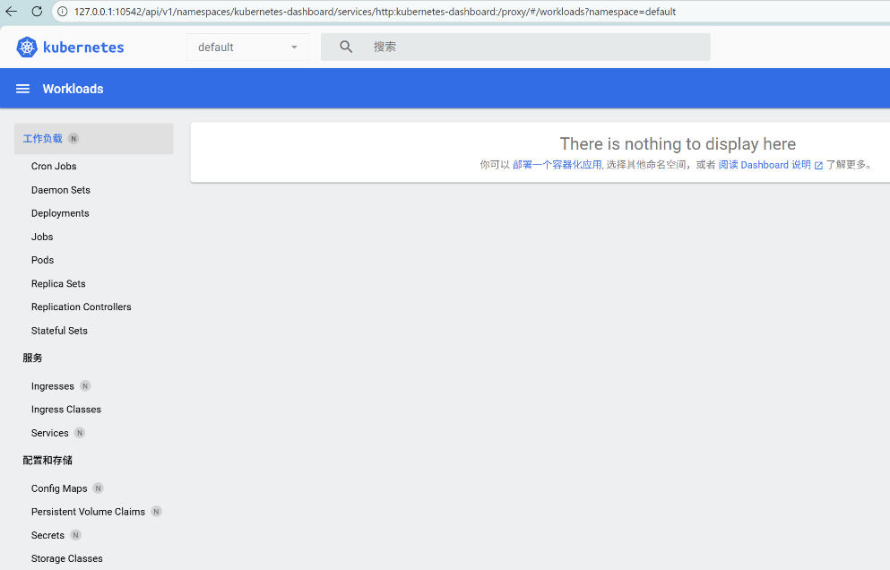

1.2 Create a Deployment
Use the kubectl create command to create a Deployment that manages a Pod. The Pod runs a Container based on the provided Docker image.
View the Deployment:
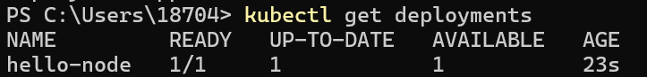
View the Pod:
View cluster events:
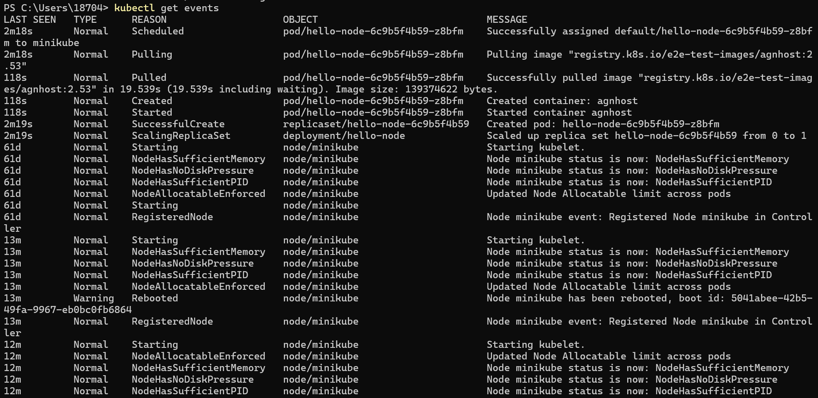
View the kubectl configuration:
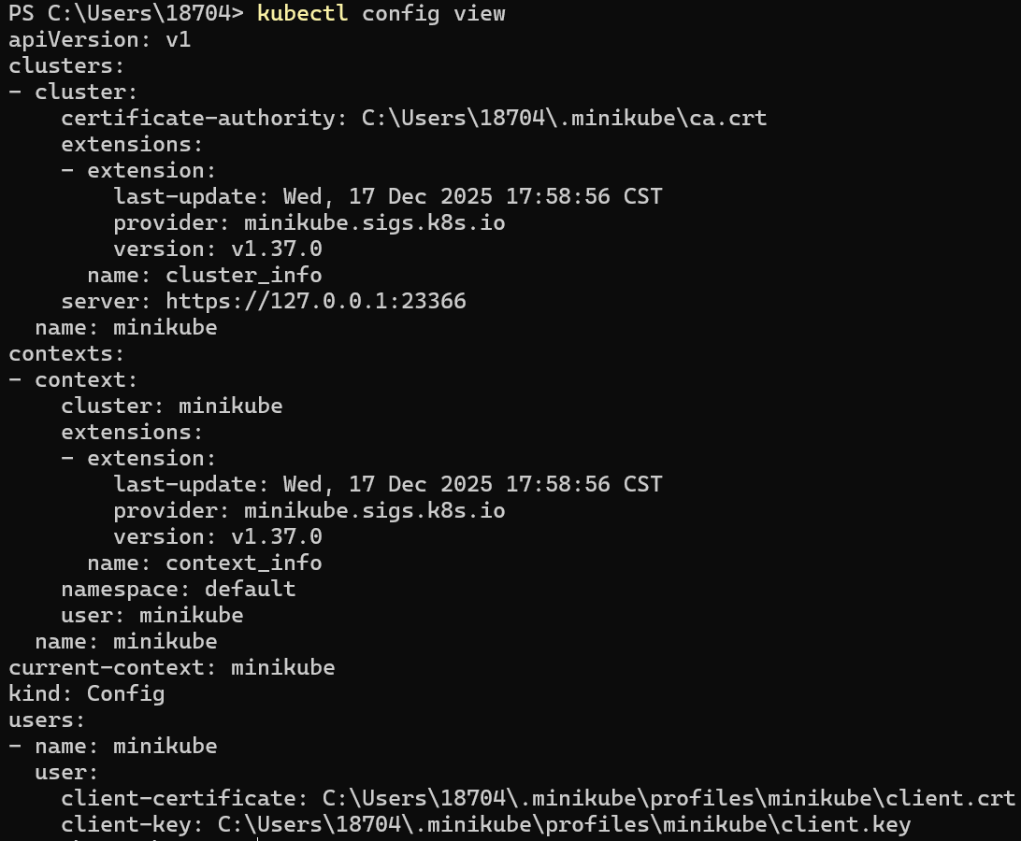
View application logs for a container in a pod (replace pod name with the one you got from kubectl get pods).

1.3 Create a Service
Expose the Pod to the public internet using the kubectl expose command. View the Service we created:
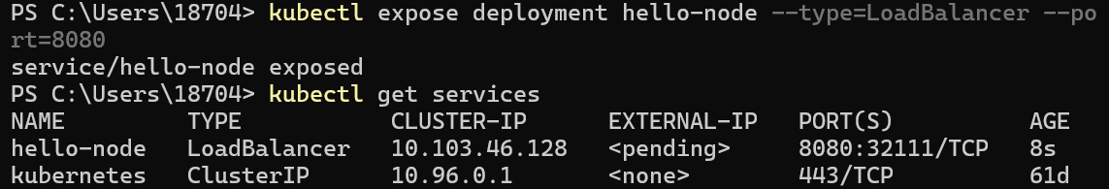
Run the following command, this opens up a browser window that serves our app and shows the app's response.
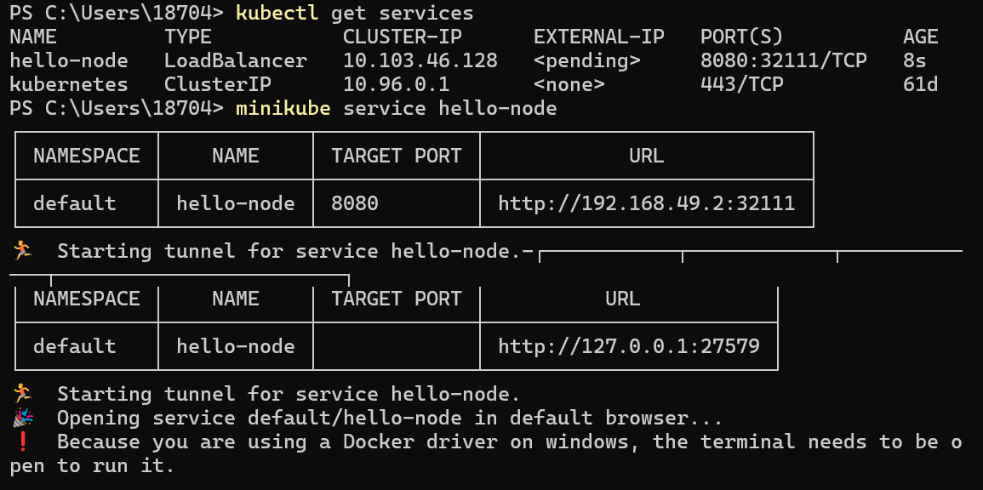
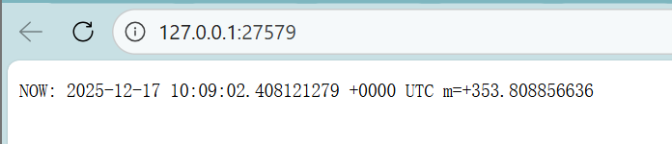

1.4 Enable addons
List the currently supported addons:
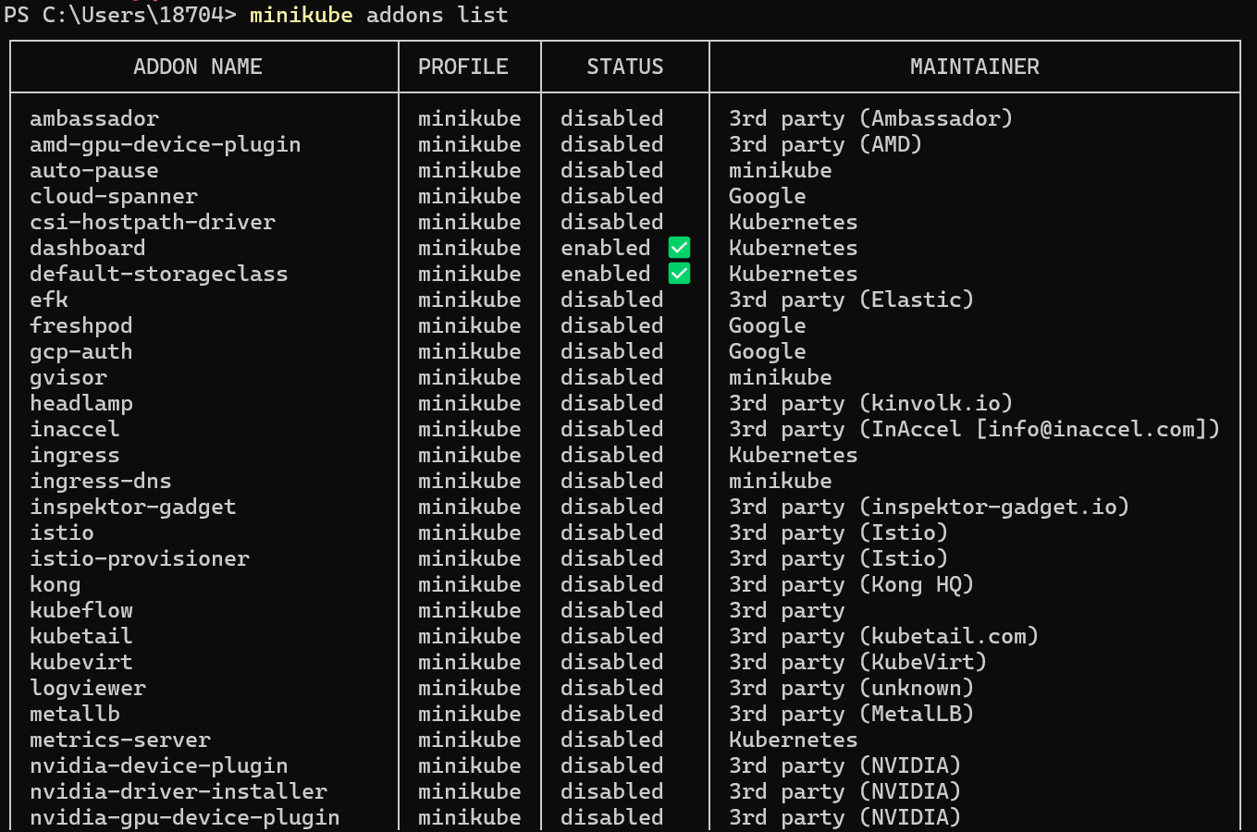
Enable an addon, for example, metrics-server:
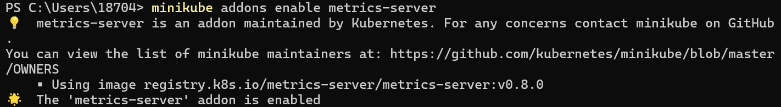
View the Pod and Service we created by installing that addon:
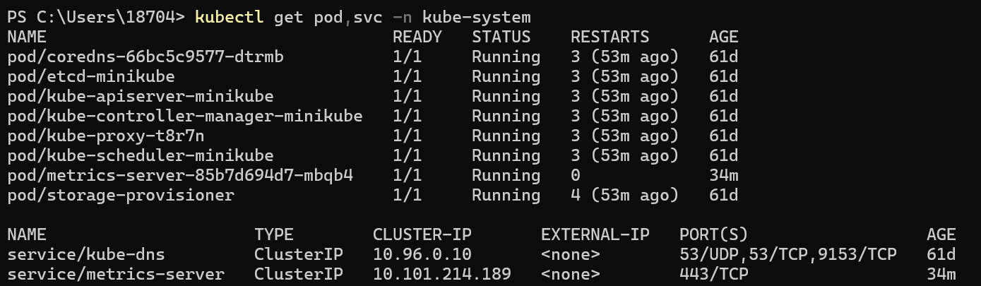
Check the output from metrics-server:
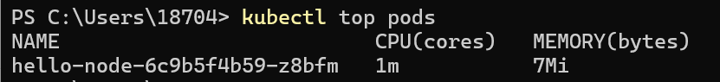
Disable metrics-server:

2.Using kubectl to Create a Deployment

2.1 Deploy an app
Let’s deploy our first app on Kubernetes with the kubectl create deployment command. We need to provide the deployment name and app image location (include the full repository url for images hosted outside Docker Hub).
To list your deployments use the kubectl get deployments command:
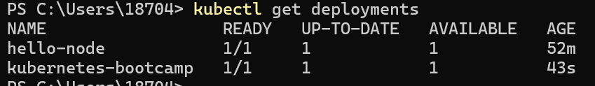
We see that there is 1 deployment running a single instance of our app. The instance is running inside a container on our node.

2.2 View the app
The kubectl proxy command can create a proxy that will forward communications into the cluster-wide, private network. The proxy can be terminated by pressing control-C and won't show any output while it's running.
We now have a connection between our host (the terminal) and the Kubernetes cluster. The proxy enables direct access to the API from these terminals.
We can see all those APIs hosted through the proxy endpoint. For example, we can query the version directly through the API:
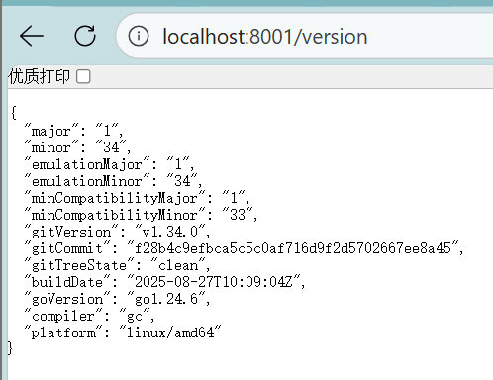
The API server will automatically create an endpoint for each pod, based on the pod name, that is also accessible through the proxy.
First we need to get the Pod name, and we'll store it in the environment variable POD_NAME.

3. Viewing Pods and Nodes

3.1 Check application configuration
We'll use the kubectl get command and look for existing Pods:
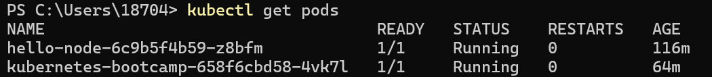
Next, to view what containers are inside that Pod and what images are used to build those containers we run the kubectl describe pods command:
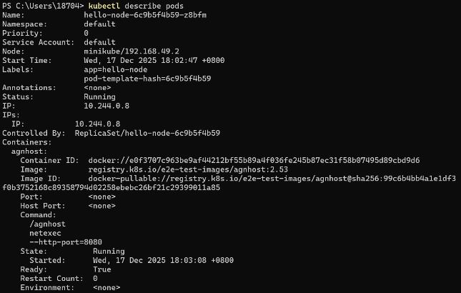

3.2 Executing commands on the container
We can execute commands directly on the container once the Pod is up and running. For this, we use the exec subcommand and use the name of the Pod as a parameter. Let’s list the environment variables:
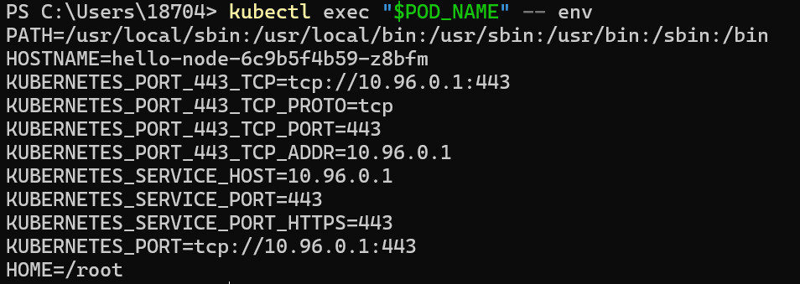
Next let’s start a bash session in the Pod’s container:
We can check the application is up by running a curl command:

4. Using a Service to Expose App

4.1 Creating a new Service
Let’s verify that our application is running. We’ll use the kubectl get command and look for existing Pods.
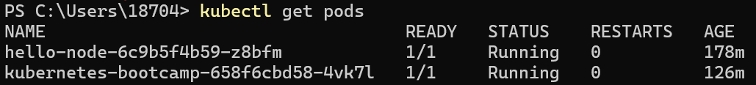
Next, let’s list the current Services from our cluster:
To expose the deployment to external traffic, we'll use the kubectl expose command with the --type=NodePort option:
To find out what port was opened externally (for the type: NodePort Service) we’ll run the describe service subcommand:
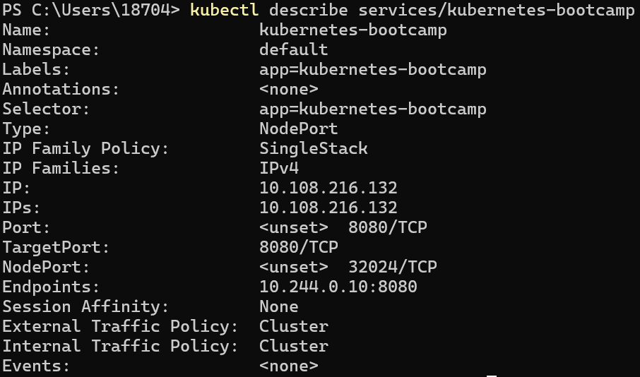
Create an environment variable called NODE_PORT that has the value of the Node port assigned:
Now we can test that the app is exposed outside of the cluster using curl, the IP address of the Node and the externally exposed port.
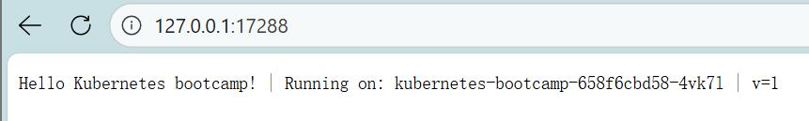

4.2 Using labels
The Deployment created automatically a label for our Pod. With the describe deployment subcommand you can see the name (the key) of that label:
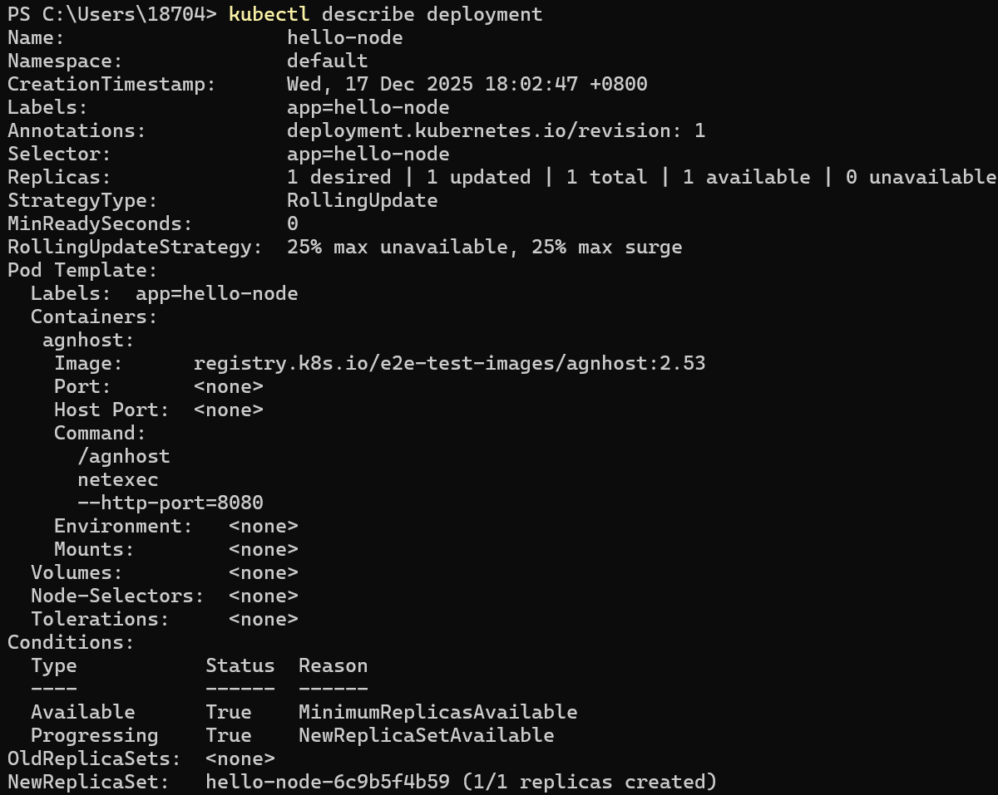
Let’s use this label to query our list of Pods. We’ll use the kubectl get pods command with -l as a parameter, followed by the label values.
We can do the same to list the existing Services.
Get the name of the Pod and store it in the POD_NAME environment variable.
To apply a new label we use the label subcommand followed by the object type, object name and the new label. This will apply a new label to our Pod (we pinned the application version to the Pod), and we can check it with the describe pod command.
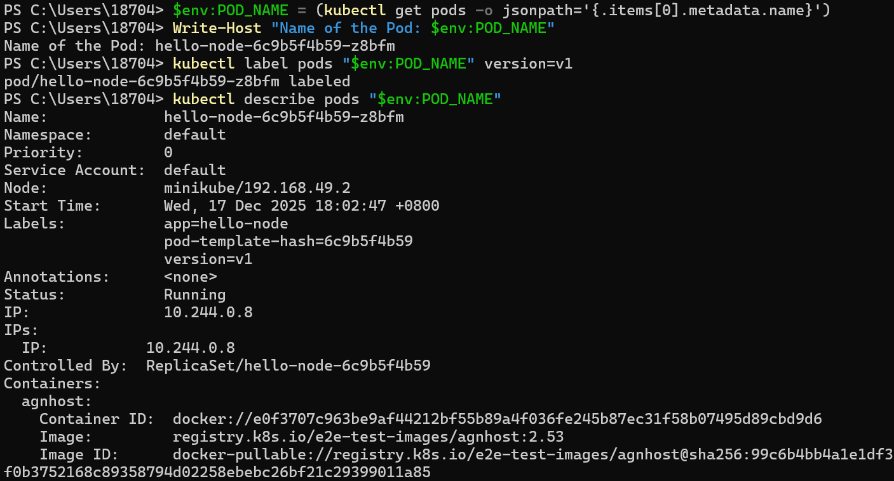
We see here that the label is attached now to our Pod. And we can query now the list of pods using the new label:

4.3 Deleting a service
To delete Services you can use the delete service subcommand. Labels can be used also here:
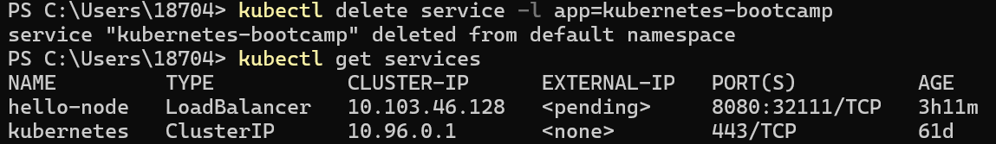

5. Running Multiple Instances of our App

5.1 Scaling a Deployment
To list our Deployments, use the get deployments subcommand:
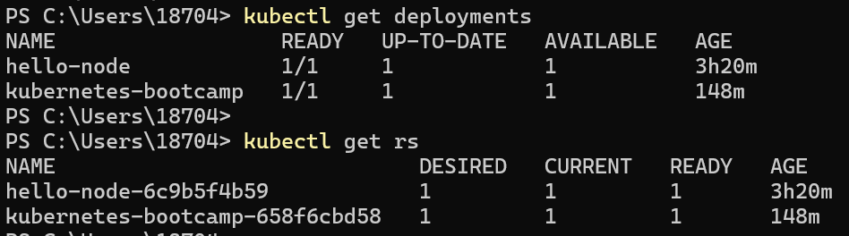
Next, let’s scale the Deployment to 4 replicas. We’ll use the kubectl scale command, followed by the Deployment type, name and desired number of instances:
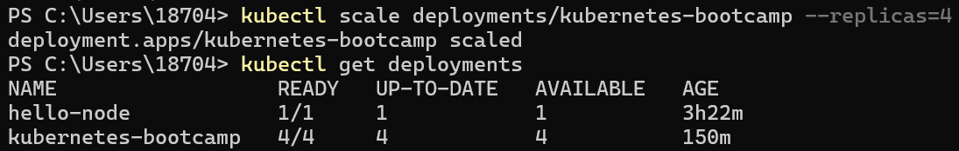
The change was applied, and we have 4 instances of the application available. Next, let’s check if the number of Pods changed:
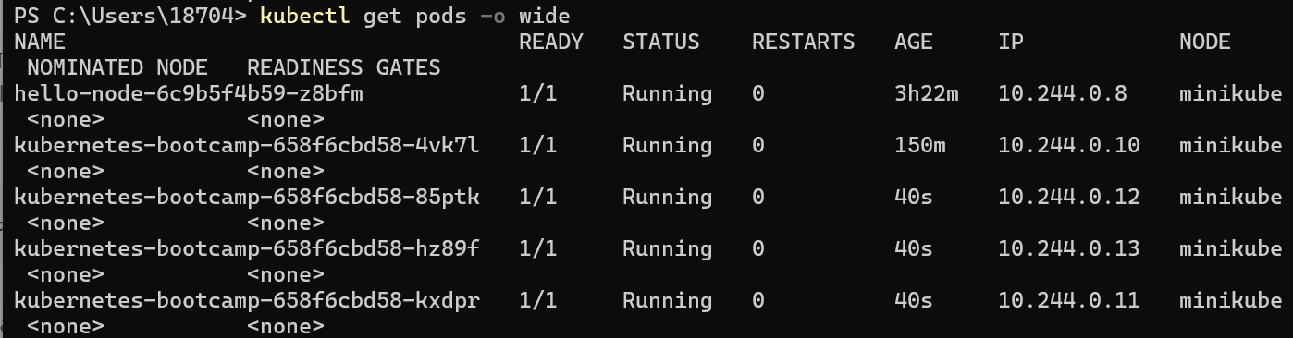
There are 4 Pods now, with different IP addresses. The change was registered in the Deployment events log.
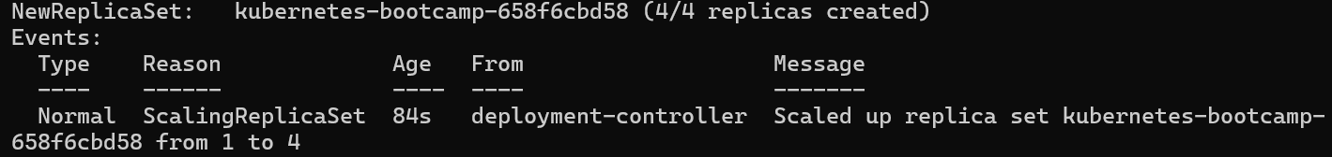

5.2 Scale Down
To scale down the Deployment to 2 replicas, run again the scale subcommand:
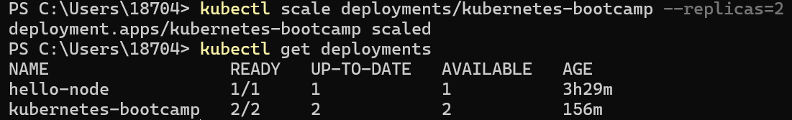
The number of replicas decreased to 2. List the number of Pods, with get pods:
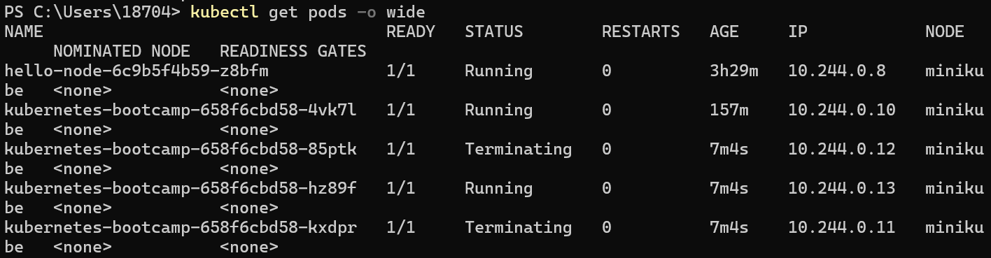

6. Performing a Rolling Update

6.1 Update the version of the app
List our deployments and list the running Pods.
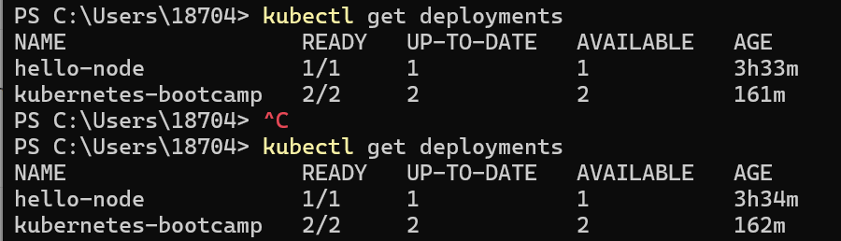
To update the image of the application to version 2, use the set image subcommand, followed by the deployment name and the new image version:
The command notified the Deployment to use a different image for your app and initiated a rolling update. Check the status of the new Pods, and view the old one terminating with the get pods subcommand:
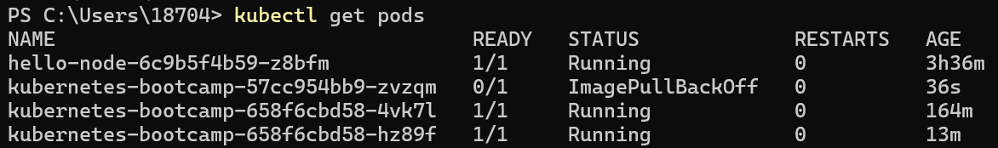

6.2 Verify an update
First, check that the service is running.
We can confirm the update by running the rollout status subcommand:

6.3 Roll back an update
Let’s perform another update, and try to deploy an image tagged with v10. Use get deployments to see the status of the deployment.
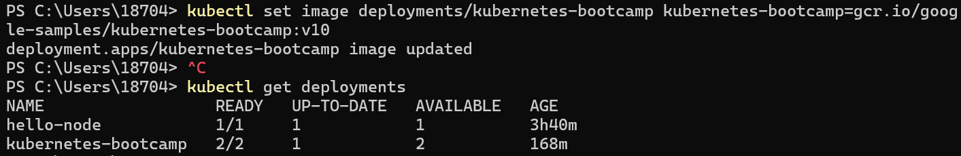
Notice that the output doesn't list the desired number of available Pods. Run the get pods subcommand to list all Pods:
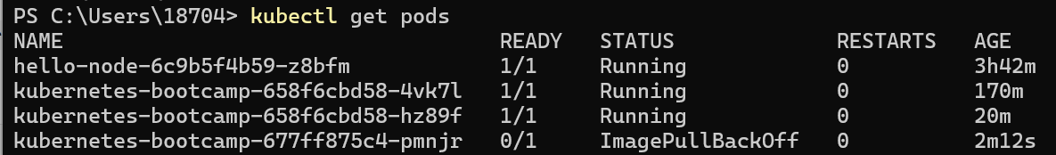
To roll back the deployment to your last working version, use the rollout undo subcommand:
The rollout undo command reverts the deployment to the previous known state (v2 of the image). Updates are versioned and we can revert to any previously known state of a Deployment. Use the get pods subcommand to list the Pods again:
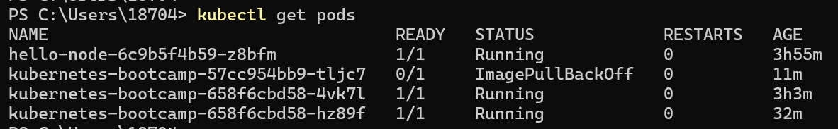
The Deployment is once again using a stable version of the app (v2). The rollback was successful. Then, Clean up our local cluster.
